Project Tracker

Iteration #5 Plan

12/1/2014 – 12/8/2014

# Revision History

|  |  |  |
| --- | --- | --- |
| **Author** | **Date** | **Description** |
| M. Rudner | 12/1/2014 | Initial Release |
| M. Rudner | 12/12/2014 |  |
| M. Rudner | 12/13/2014 | Fix bugs |

# Objectives

The purpose of this iteration is to:

* Add mobile capabilities
* Add an audit trail of changes made
* Assign an ambassador or mentor to multiple schools
* Be able to attach files to a project
* As an ambassador or mentor, should be able to see all the projects assigned to my assigned school
* Create better usability
* Added a up vote ability for viewable project ideas

# Use Cases

The following use cases are involved in this iteration:

* UC001: Submit a project idea
* UC002: View a table of submitted project idea
* UC005: Edit projects
* UC003: Assign projects to schools
* UC006: View assigned projects

# Task Schedule

|  |  |  |  |  |  |  |  |
| --- | --- | --- | --- | --- | --- | --- | --- |
| **Story ID** | Task | Effort | | Completion Date | | Owner | **Status** |
| **Est.** | **Actual** | **Est.** | **Actual** |
| S27, S25, S29 | Update models | 1 hour | .85 hour | 12/10 | 12/10 | Suenaga | Finished |
| S27 | Add dropdowns to add school | 30 minutes | .1 hour | 12/10 | 12/10 | Suenaga | Finished |
| S27 | Add dropdowns to edit school | hour | .5 hour | 12/10 | 12/10 | Suenaga | Finished |
| S27 | Update school detail to show lists of ambassador & mentors | 4 hours | .50 hours | 12/10 | 12/10 | Suenaga | Finished |
| S27 | Update schools’ lists view to show the number of ambassadors & mentors | 1 hour | .50 hours | 12/10 | 12/10 | Suenaga | Finished |
| S27 | Add controller logic to remove ambassador/mentor assignments from school when deleting, to avoid foreign key constraint violation | 1 hour | .25 hours | 12/13 | 12/13 | Suenaga | Finished |
| S27 | Let ambassador/mentor edit any project assigned to any of their schools | 1 hour | .25 hours | 12/13 | 12/13 | Suenaga | Finished |
| S34 | Added “My Schools” checkbox | 1 hour | 1 hour | 12/10 | 12/10 | Suenaga | Finished |
| S25 | Add attachment table | 1 hour | .25 hours | 12/10 | 12/10 | Suenaga | Finished |
| S25 | Create controller & update school edit form | 5 hours | 5 hours | 12/10 | 12/10 | Suenaga | Finished |
| S25 | Update school & employee details view | 1 hour | .50 hours | 12/10 | 12/10 | Suenaga | Finished |
| S25 | Add attachment functionality to submit form | 1 hour | .50 hours | 12/13 | 12/13 | Suenaga | Finished |
| S25 | Add “Size” column in attachment list | .5 hour | .5 hou | 12/13 | 12/13 | Suenaga | Finished |
| S29 | Update details view for project to show latest edit | 1 hour | .1 hours | 12/10 | 12/10 | Suenaga | Finished |
| S29 | Add a view that shows all edits for a particular project | 1 hour | .3 hours | 12/10 | 12/10 | Suenaga | Finished |
| Edits to site from usability test | Add description of site to login page | 1 hour | 2 hours | 12/10 | 12/10 | Suenaga | Finished |
| Edits to site from usability test | Replace gold star with green “Your idea” label | .3 hours | .3 hours | 12/10 | 12/10 | Suenaga | Finished |
| S32 | Added “Per Page” dropdown with choices 5, 10, 25, 50 | 1 hour | 2 hours | 12/12 | 12/12 | Suenaga | Finished |
| S19 | Update Project & Employee models | .30 hours | .05 hours | 12/12 | 12/12 | Suenaga | Finished |
| S19 | Add Votes column to Projects list | 0.30 hours | .05 hours | 12/12 | 12/12 | Suenaga | Finished |
| S19 | Add sorting for Votes column | 0.30 hours | 0.1 | 12/12 | 12/12 | Suenaga | Finished |
| S19 | Add button in Votes column to vote for project | 0.30 hours | 1 | 12/12 | 12/12 | Suenaga | Finished |
| S19 | Add Vote action to Project controller, to toggle vote for user | 0.30 hours | 0.15 hours | 12/12 | 12/12 | Suenaga | Finished |
| S19 | Add Project Votes view that lists everyone who's voted for a particular project | 0.30 hours | 0.05 hours | 12/12 | 12/12 | Suenaga | Finished |
| S19 | Put vote button HTML into HtmlBuilder helper | 0.30 hours | 0.75 hours | 12/12 | 12/12 | Suenaga | Finished |
| S19 | Add Vote button & count in Project & Employee details views | 0.30 hours | 0.75 hours | 12/12 | 12/12 | Suenaga | Finished |
| S19 | Fixed broken vote button for non admins in Project details view | .15  Hours | .15 hours | 12/13 | 12/13 | Suenaga | Finished |

# Task Pictures

## Shows audit trail if edits of two or more have been made:

## 

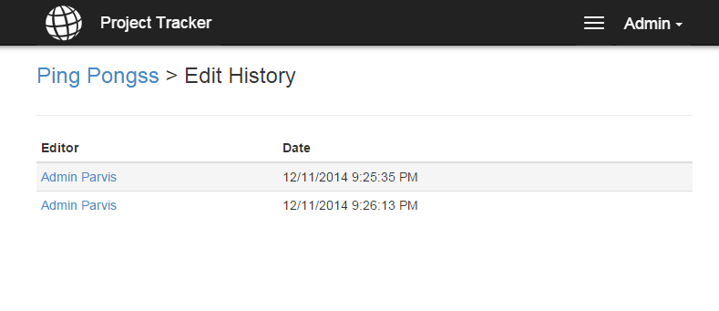

## Add an ambassador to multiple schools:

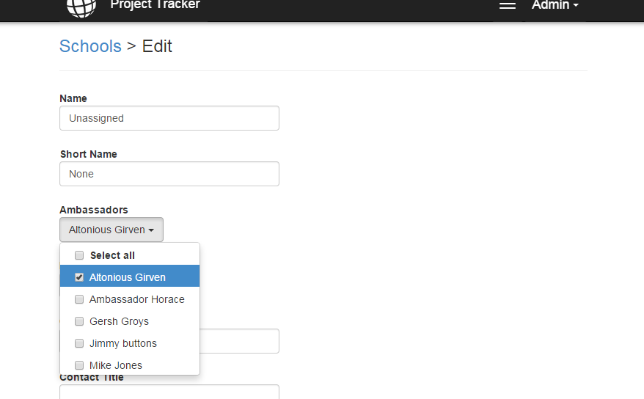

## Added file attachments to projects:

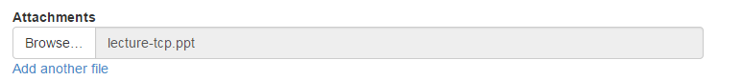

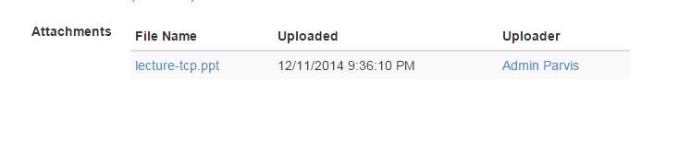

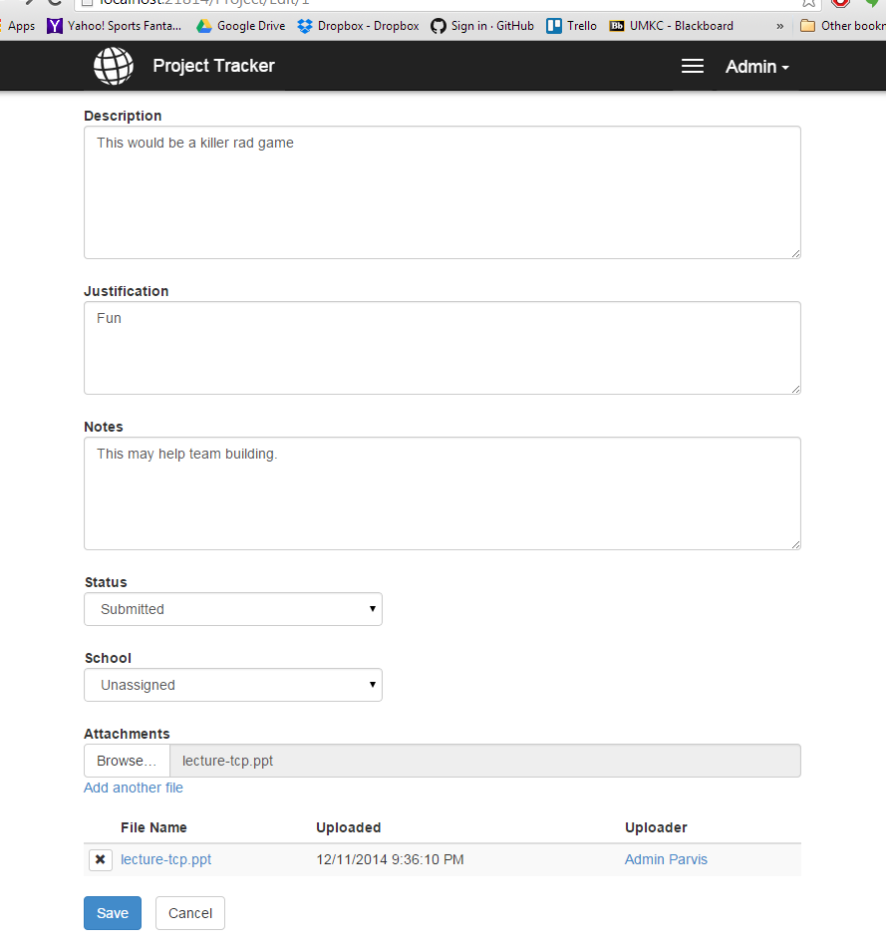

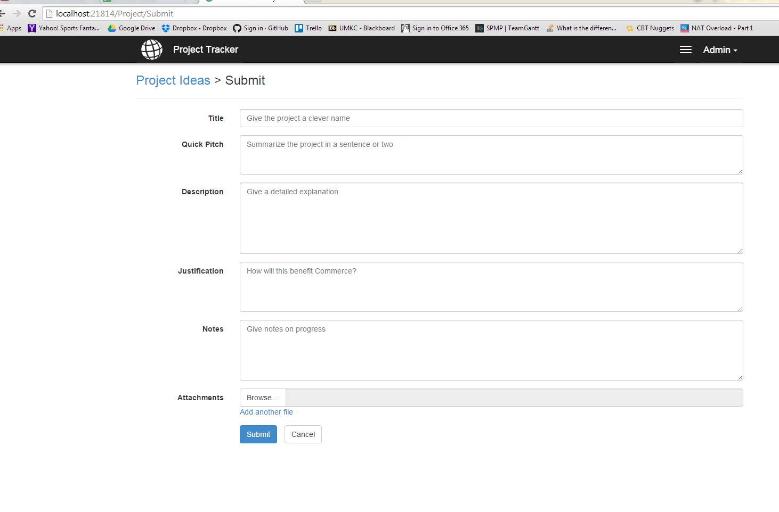

## Ambassador should be able to see all the projects assigned to a school:

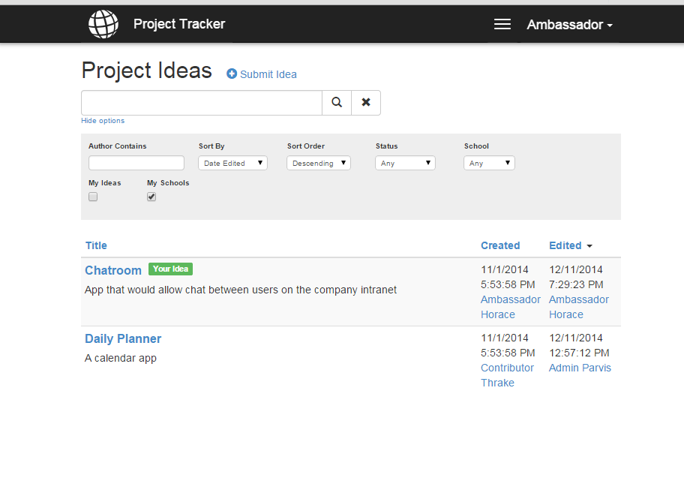

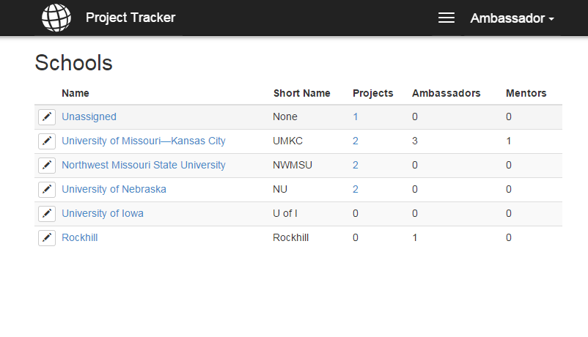

## Changed star to “Your Idea” icon:

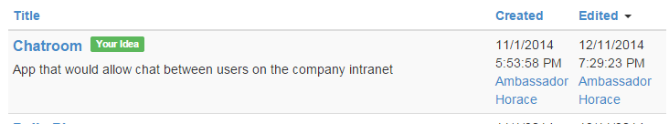

## Added a description of site to log in page. Changed “Remember me?” to “Keep me logged in”:

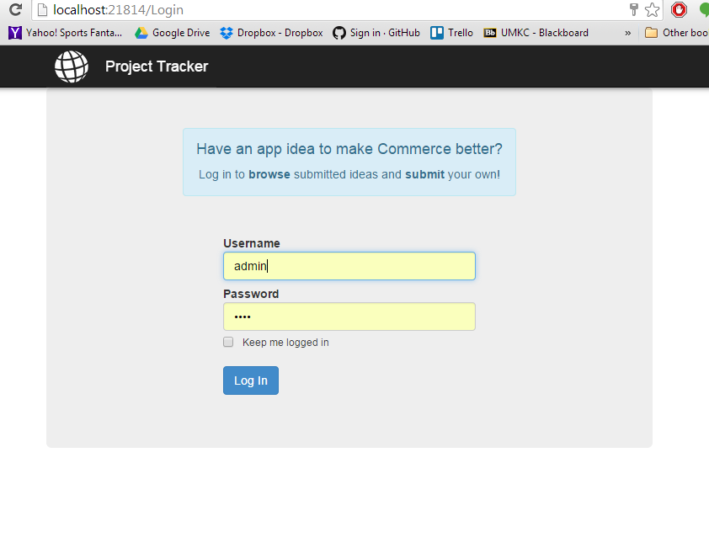

## Added paginated view:

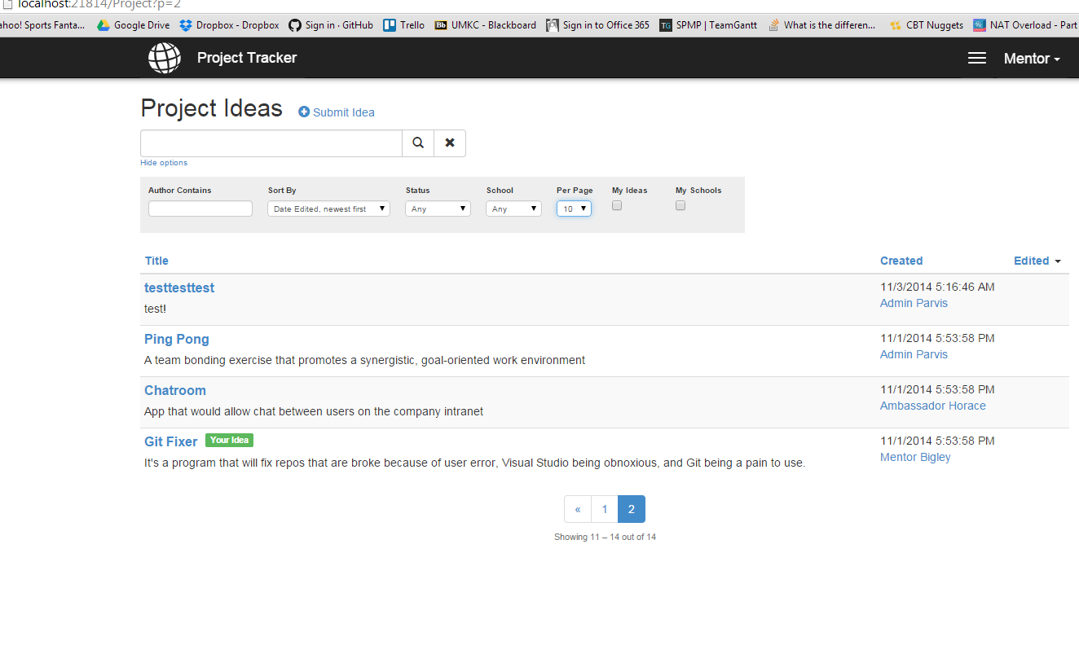

## Added an up vote:

